主标题：pda barcode scanner

副标题：HT600 6 inch pda barcode scanner
Key features:
8 core 2.2GHz,Android 13,4G+64G
6-inch screen
2G,3G,4G wireless communication,NFC
Barcode, QR code scanning

HT600 high-performance PDA barcode scanner
pda barcode scanner -1
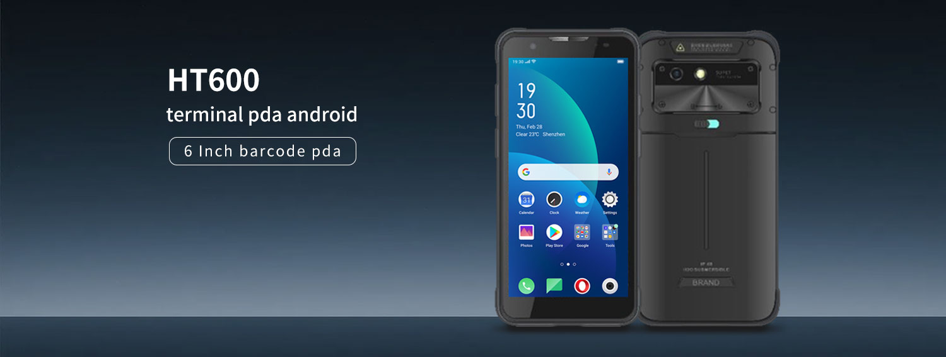
LQYCIT independently created the HT600, their flagship intelligent pda barcode scanner. It is developed to handle today's complex industry concerns by combining powerful processing speed, advanced data collection capabilities, and top-tier industrial protection levels. With the Android 13 operating system, a high-performance eight core CPU, and a 6.0-inch high-definition screen, the HT600 is the ideal companion for enhancing operational efficiency and attaining speedy information management in logistics, retail, warehousing, medical, and other industries.
pda barcode scanner -2
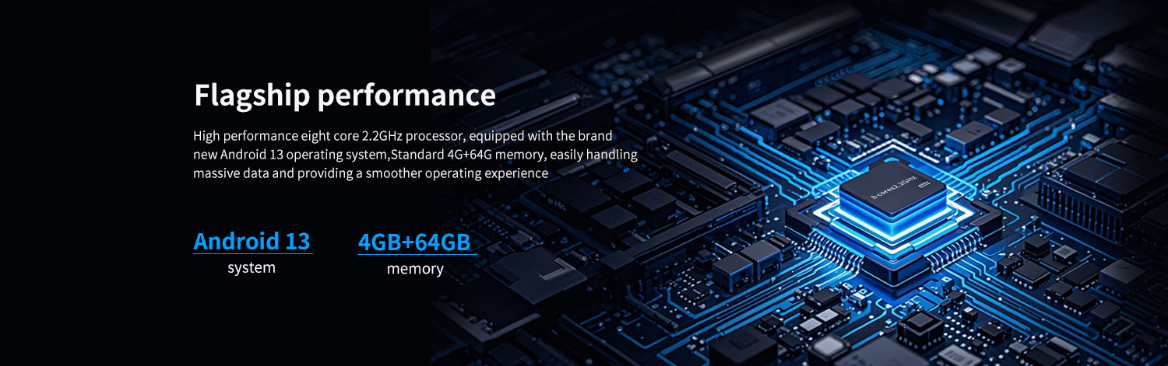
Powerful performance and efficiency core
The HT600 pda barcode scanner is by a high-performance eight core 2.2GHz CPU that can give lightning-fast responsiveness while running complex WMS and ERP systems and processing huge inventory data. It comes with the brand-new Android 13 operating system, which provides a better working experience, improved application compatibility, and enhanced enterprise-level data security protection.
pda barcode scanner -3
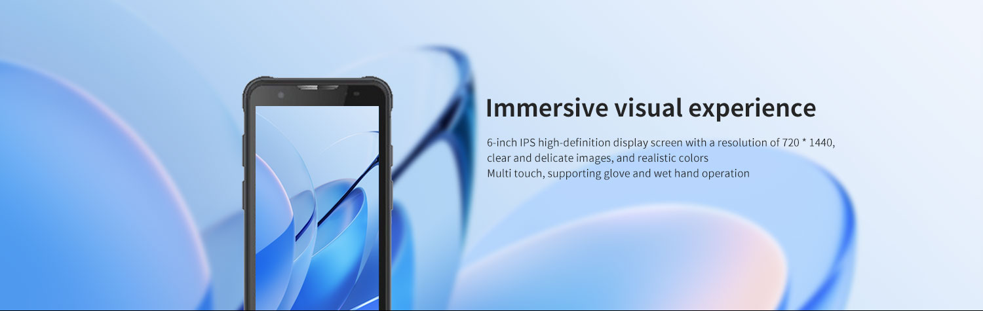
Immersive visual experience, control of the total scenario
The 6.0-inch FHD+high-definition display screen produces a crisp and sensitive image with genuine colors. Industrial-grade high brightness screens provide good visibility even in intense outdoor lighting. A larger screen provides a more interactive experience. The back 16 megapixel camera has autofocus, making it simple to take high-quality on-site images while also giving clear documentation for damaged items and equipment inspections.
pda barcode scanner -4
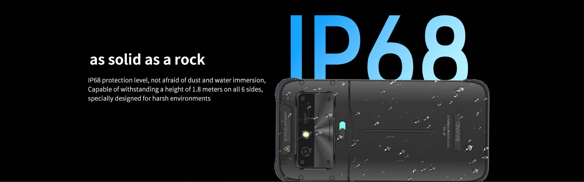
As strong as a rock, fearless of obstacles.
HT600 pda barcode scanner can work reliably in crowded warehouses, humid outdoor conditions, and filthy manufacturing. LQYCIT independently produced this masterpiece, which meets IP68 dust and waterproof specifications and has passed rigorous industrial drop tests. The strong and resilient design greatly minimizes equipment failure rates, ensuring company continuity.
pda barcode scanner -5
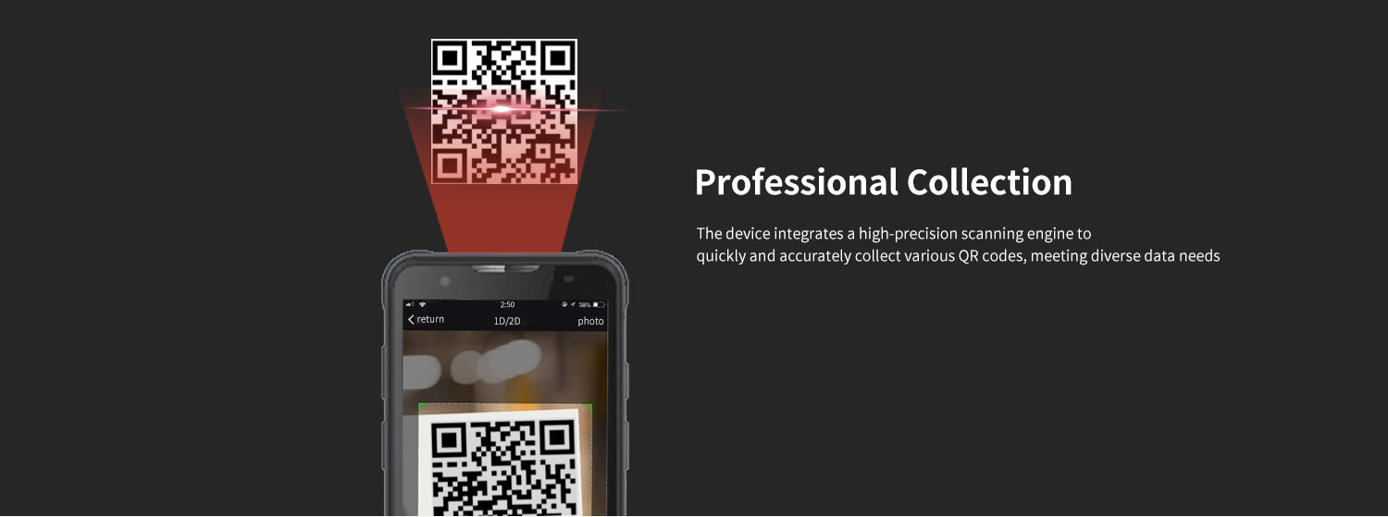

data collection
Barcode scanning: comes standard with professional barcodes and a QR code scanning engine. Whether it's stains, reflections, or long-distance barcodes, it can achieve precise and fast "scan and get".
pda barcode scanner -6
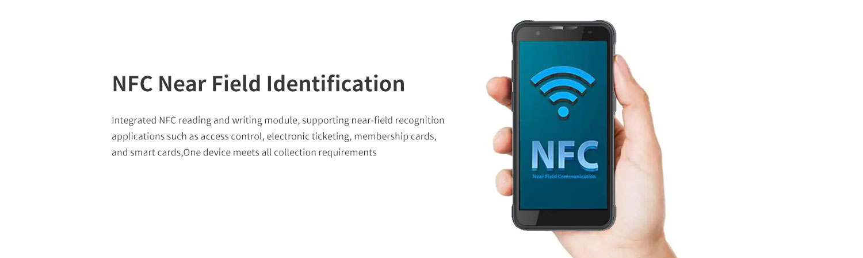
NFC function
Integrated NFC read-write module, operating frequency: 13.56MHz; Protocol standards: Supports ISO14443A/B and 15693 protocols; Perfectly supports near-field recognition applications such as employee cards, membership cards, device tags, and smart cards.

Ultra long battery life, online all day long
Equipped with an 8000mAh large capacity detachable battery, supporting fast charging technology and the ability to replace RTC batteries without shutting down. Ensure that the equipment can still support full shift operation under high-intensity use without frequent charging.



